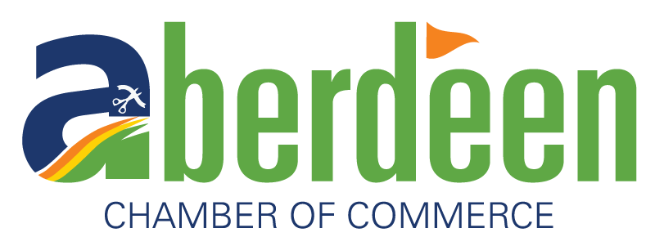

The following members of the Aberdeen Area Chamber of Commerce proudly accept the Aberdeen Gift Card as payment for products or services at their business. Be sure to check the balance on your card prior to your purchase!
6th Ave Pit Stop
A & B Business, Inc.
Aberdeen American News
Aberdeen Aquatics Center
Aberdeen Area Arts Council
Aberdeen Dental Associates
Aberdeen Family YMCA
Aberdeen Floral, LLC
Aberdeen Hub Area BMX
Aberdeen Massage
Aberdeen Monument
Aberdeen Parks, Rec & Forestry
Aberdeen Pit Stop
Aberdeen Smiles
Aberdeen Wings
Aerial Arts by Avery
Aiport Travel Center & Café
Allevity Entertainment
Animal Care Clinic
Arby’s
Artz Equipment, Inc.
AutoMaxx
Avera Family Physicians
Avera Medical Ear, Nose & Throat
B & E Siding & Windows
Barnett Vision Center, L.L.P.
BeMobile
Best Carpet Cleaning
Best Western Ramkota Hotel

Bonn Express
Boss Baby Boutique, The
Boston Fern, The
Bremer Photography
Brides ‘N Belles
Budget Furniture
Buffalo Wings & Rings
Builder’s First Source
Bur-Mar’s Clothing, Shoes & Accessories
Campbell's Town & Country
Caribou Coffee Inc.
Carrels and Bain Family Dental
Casey's General Stores, Inc.
Catching Fireflies Boutique
C-Express – All Locations
City Lights Bar and Event Center
CJ’s Patisserie
Colorful Creations LLC
CommTech Inc
Conklin Clinics
Corner Book Shoppe, The
Court Street Lighting
Culver's of Aberdeen
D’s Fast Food & Catering
Dacotah Prairie Museum
Dairy Queen
Dakota Electronics
Dakota Event Center
Dakota Outdoors
Dakota Plastic Surgery

Danger von Dempsey’s Pizza +
Brewhaus
Diamond Dry Cleaning
Domino's Pizza
Double D Body Shop
Economy Meat Market
Family Dental Care
Flame Steakhouse, The
Gas-N-Goodies
Geffdog Design & Apparel
Gelling’s Auto Service
Gliks
Goodwill of the Great Plains
Graham Tire Co. of Aberdeen
Guadalajara Mexican Restaurant
Haggerty’s Music
Hair Addictions
Hampton Inn & Suites
Happy Health Shack
Harr Motors
Hearing Care Professionals
Heart & Sole Foot Zone Therapy
Heiser’s Jewelry
Hepper's Sport Center
Hitch'N Post Western Store
Holiday Inn Express
House of Glass
Hub Area Habitat for Humanity
Hub City Axe Throwing
Interior Design Concepts
Jimmy's Pizza
JLM Golf LLC
Junction, The
Karisma Boutique
Karl's TV, Audio & Appliance
Ken’s SuperFair Foods &
Shell Express
Kesslers Food & Liquor
Lager’s Inn
Lang's Audio, TV & Appliance
Lee Park Golf Course
Lily’s Floral Design & Gifts
Mack’s Auto Body
Mainstream Boutique
Matheson Tri-Gas
Mattress By Appointment
McDonald’s – All Locations
Medicine Rock
Mid Star Lab, Inc.
MIDCO
Midwest Ag Supply, LLC
Miller & Holmes – M & H Gas
Millstone Family Restaurant
Minerva's
Moccasin Creek Country Club
My Place Hotel - Aberdeen, SD
Natural Abundance Food Co-op
Northern Electric Cooperative
Northern Plains Animal Health
NSU Book Store
Northern Valley Communications
Northwestern Energy
Ophthalmology Associates
OZ Motorz
Parkview Nursery
Pauer Sound & Music
Photo-X-Press
Pierson Ford Lincon Inc.
Pinned Workshop
Pit Crew Row
Pizza Ranch
Presentation College Book Store
Profile by Sanford
Profiling Beauty
Qdoba Mexican Grill
Quality Inn
Quality Quick Print
RDO Equipment Co.
Red Rooster Coffee House
Revive Day Spa
Riddle's Jewelry
Ridgeline Massage Therapy
Rohly’s Bar
Roma Ristorante Italiano
Running’s
Sammy’s Restaurant
Sanford Health Aberdeen Clinic
Shoe Science
Shoe Sensation Inc
Skal Moon
Slackers
SoDak Sports
SoulShine Massage Therapy South C Store
Steven Lust Automotive
Subway (All Aberdeen Locations)
Sun City Aberdeen
Super 8
Taco John’s
Thatzza Pizza
The Boss Baby Boutique
The Fuze
The Market on the Plaza
Tip & Toe Nails
TM Fitness
T-N Tax Business Services, Inc.
TownePlace Suites by Marriott
Twist Cone
Ultimate Kitchen & Bath
United Clinic Pharmacy
UPS Store, The
Valvoline Instant Oil Change – Thor’s Car Wash
Van Laecken Orthodontics
Vision Care Associates LLP
Wakeside Bar & Grill
Wal-Mart Super Center
Wendy's
West Oak
Winkler Chiropractic Clinic
Wireless World
Wylie Park Campground, Concessions & Gift Shop
Wylie Thunder Road Go-Karts & Mini-Golf

