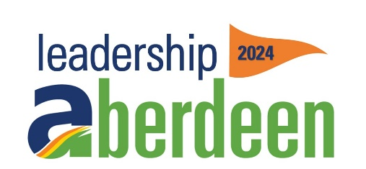
Project Sponsorship Form
Leadership Aberdeen Baird Park Snow Hill
Help us purchase and install a snowmaking machine

King of the Hill Tier = $5000+
Company name listed on sponsor board recognizing King of the Hill sponsorship.
Picture with large check posted on social media and Aberdeen chamber website.
Platinum Tier = $2,500 – 4,999
Company name listed on sponsor board recognizing Platinum sponsorship.
Picture with large check posted on social media and Aberdeen chamber website.
Gold Tier = $1,000 - 2,499
Company name listed on sponsor board recognizing Gold sponsorship.
Picture with large check posted on social media and Aberdeen chamber website.
Silver Tier = $500 -999
Company name listed on sponsor board recognizing Silver sponsorship.
Picture with large check posted on social media and Aberdeen chamber website.
Bronze Tier = $ UP TO $499
Name listed as donor on Aberdeen chamber website.

Business Name: ______________________________________________________________
Contact Name: _______________________________________________________________
Contact Phone: _______________________________________________________________
Contact E-mail: _______________________________________________________________

Sponsor $_________________________

Please mail this completed sponsorship form to Gail Ochs, 516 S Main St, Aberdeen, SD 57401 or e-mail to gail@aberdeen-chamber.com. Make checks payable to City of Aberdeen or Aberdeen Parks, Recreation and Forestry Department

