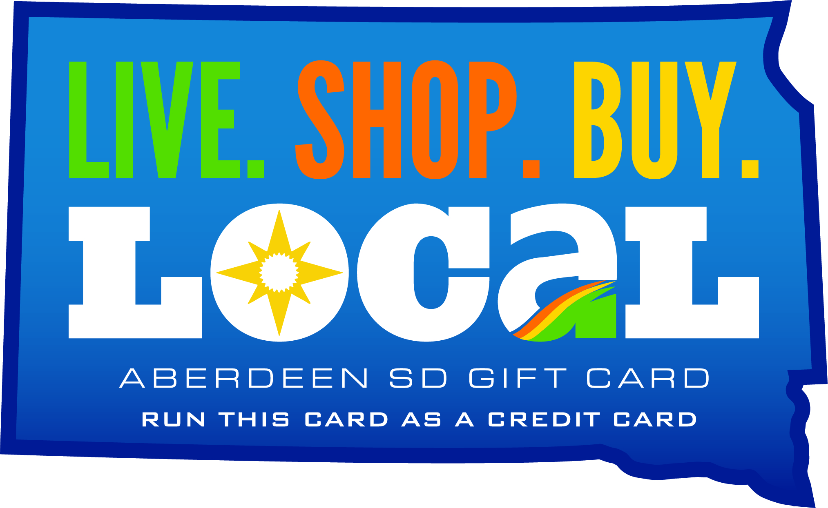

HOW TO USE YOUR ABERDEEN GIFT CARD

Determine Gift Card Balance

- Make sure you know the balance on your Aberdeen Gift Card before you use it as the card will decline if sale amount exceeds balance on card.
- Check balance online at www.getmybalance.com.
- Call the Chamber at (605) 225-2860 Monday – Friday and provide card number from back of card (Ex:1234 5678 9012 3456).
- Call the automated phone line at 1-800-755-0085 found on back of card and provide them with card number.
- Purchase an inexpensive item and look at your receipt. Authorization code on receipt will display the actual remaining card balance as shown here:
MERCHANT NAME
123 MAIN STREET
DATE 05/01/09 TIME 10:42 PM
ITEM: 020 SALE $100.00
ACCT: xxxxxxxxxxxxxxxx xxx
AUTHORIZATION CODE: 127X64
I AGREE TO PAY ABOVE TOTAL AMOUNT ACCORDING TO CARD ISSUER AGREEMENT
X_____________________________
SIGNATURE

SHOWS BALANCE REMAINING OF $127.64

Self-Checkout Processing


- Ensure the card has sufficient funds as shown above.
- Simply use the credit card key at the register. Do not use gift card, gift certificate, check, travelers check or any other key.
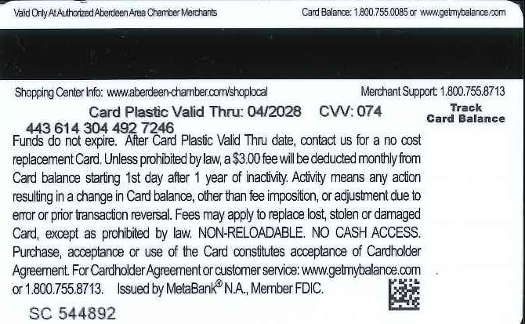
- If it requires that you input the CVV number, it is located here.
- If it requires the last 4 digits of a bank card to complete an authorization, enter the 4th set of numbers on the back of the card (Ex: 443 614 304 492 7246).
- If the POS requires the expiration date, it is the number here: Card Plastic Valid Thru.

Back of Card
- Split Tender Transactions
- If your Aberdeen VISA gift card does not have sufficient funds to cover the total amount of the sale, you must process the sale as a split tender transaction and use another form of payment for the amount of the sale that exceeds the gift card balance.
- Process the NON-ABERDEEN CHAMBER GIFT CARD transaction FIRST.
- Swipe the gift card last to authorize the remaining amount of the sale which equals balance on card.

Manual Entry
- If the system fails to read the card when swiped, or if the system is not set up to do so, you can type in the 16-digit code on the back of the card.

Returns
- Returns can be placed back on the card; however, it may take up to 3 business days to appear on your gift card account.

Reasons Card May Decline
- Sale exceeds balance of the card – see above for split-tender transactions.
- The merchant may have updated their POS system and they need to contact the Chamber to re-activate their system.
- Card has been inactive for over one year. EML Financial will deduct $3.00 per month until a purchase is made, or the card balance is depleted.

Additional Program Information
- The Aberdeen Gift Card Program is facilitated by the Aberdeen Area Chamber of Commerce. Cards can be purchased at the Chamber office located at 516 S Main St., Aberdeen, SD 57401 or online at www.aberdeen-chamber.com.
- Gift cards are sold in increments from $10.00 to $500.00. There is no charge to purchase gift cards, thanks to the card sponsor, Dakota Broadcasting.
- A list of participating merchants is included with every gift card purchase and is available online at https://www.aberdeen-chamber.com/153/Aberdeen-Gift-Card-Program.

